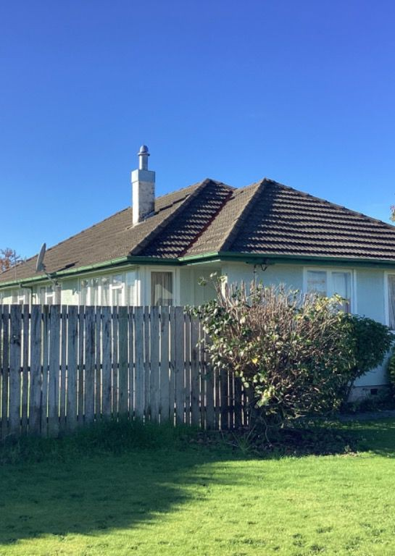


Your Building Inspection

1 Sample Street
ID 98444
Wednesday, May 11, 2022

We would like to take this opportunity to thank you for choosing Property Inspections Phuket as your building inspector.

Thank You
for choosing us
Having a property inspection carried out is beneficial for both buyers and sellers. For buyers, it provides peace of mind by ensuring that the property they are investing in is in good condition, free from hidden issues like structural damage, plumbing problems, or electrical faults. This knowledge can help buyers make informed decisions, negotiate better deals, or avoid potential money pits. For sellers, a property inspection can facilitate a smoother sales process by identifying and addressing issues before listing the property, thereby enhancing its marketability and potentially increasing its value. It also builds trust with prospective buyers, showing transparency and reducing the likelihood of last-minute negotiations or deal collapses due to unexpected findings.



Table Of
Contents

Your Report Contents

01 TRAFFIC LIGHTS

03 YOUR REPORT SUMMARY

05 EXTERIOR ROOF

07 EXTERNAL WALL CLADDING

09 PLUMBING SYSTEM

11 WEATHER TIGHTNESS

13 PESTS & HAZARDS

15 OUR TERMS & CONDITIONS
02 YOUR PROPERTY DETAILS

04 YOUR PROPERTY REPORT

06 ROOF SPACE

08 FOUNDATION & SUBFLOOR

10 ELECTRICAL SYSTEM

12 SITE IMPROVEMENTS

14 OTHER POINTS OF INTEREST


Our Traffic Lights

GREEN TRAFFIC LIGHT
G

Green illustrates that we have a low or no level of concern associated with the building element.

ORANGE TRAFFIC LIGHT
G

Orange illustrates that we have a moderate level of concern associated with the building element. Prompting caution, further investigation and/or repair be considered.

RED TRAFFIC LIGHT
R

Red illustrates that we have has a high level of concern associated with the building element. Caution and further investigation is strongly recommended.


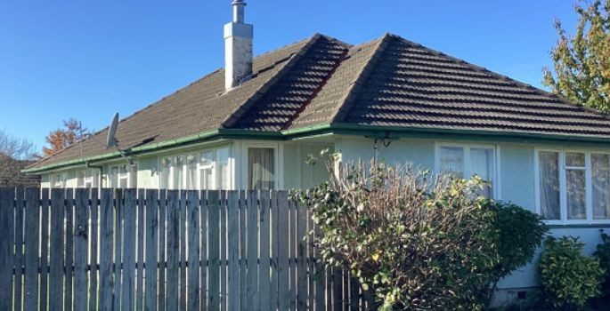
Your Inspection Details

YOUR INSPECTOR

Our Inspector
Email: Our inspector@email.com Mobile: 555 12345679

ORDER NUMBER | 98444
DATE OF INSPECTION | WEDNESDAY, MAY 11, 2022
INSPECTED PROPERTY ADDRESS | 1 SAMPLE STREET
INSTRUCTED BY | PURCHASER
CLIENT NAME | JOE BLOGGS
CLIENT PRESENT | YES
OTHER PEOPLE PRESENT | CLIENTS RELATIVES. OCCUPANT. REAL ESTATE AGENT.
HOUSE OCCUPIED | YES
WAS THE PROPERTY FURNISHED? | YES
BUILDING TYPE | RESIDENTIAL DWELLING.
STATUS OF UTILITIES | POWER ON. WATER ON.

WEATHER DURING INSPECTION
DISCLOSURE OF DEFECTS BY REAL ESTATE SALESPERSON | NONE.

GENERAL SUMMARY NOTES

On July 12, 2024, Property Inspections Phuket conducted a comprehensive inspection of a two-story villa located in the heart of Phuket's Chalong district. The villa, spanning approximately 300 square meters, featured four bedrooms, three bathrooms, a swimming pool, and a landscaped garden. The inspection covered structural integrity, electrical systems, plumbing, and overall safety.
The structural assessment revealed minor cracks in the external walls, likely due to natural settling over time. These were not deemed critical but recommended for sealing to prevent moisture ingress. The roof was in good condition with no visible leaks or damaged tiles.
Electrical inspections identified that the wiring was in a good condition, but a few outlets were loose and required securing. The circuit breaker panel was functional, with appropriate labelling for each circuit.
Plumbing systems were evaluated, revealing no major issues. However, slight corrosion was noted in some of the older piping, suggesting the need for eventual replacement to maintain optimal water flow and quality.
The swimming pool's filtration system was operational, though it was recommended to replace the pool's pump, as it was nearing the end of its functional lifespan. Safety features, including pool fencing and gate latches, met local regulations.
Overall, the villa was deemed to be in good condition with a few minor maintenance tasks recommended to ensure long-term durability and safety.

Your Report Summary

This report focuses on what we see as the nine main areas of concern for our clients when buying property. These areas are: 1. Exterior roof, 2. Roof space, 3. External wall cladding, 4. Foundation & subfloor, 5. Plumbing system, 6.

Electrical system, 7. Weather tightness, 8. Site improvements, 9. Pest & potential hazards, 10. Other points of interest
Below is a summary of the highest concern level for each focus area. Please refer to the focus area for further details.

- EXTERIOR ROOF 6. ELECTRICAL SYSTEM
G
green
O
orange
- ROOF SPACE 7. WEATHER TIGHTNESS
G
green
G
green

- EXTERNAL WALL CLADDING
G
green
8. SITE IMPROVEMENTS

orange

- FOUNDATION & SUBFLOOR 9. PEST & POTENTIAL HAZARDS
O
G
G
green
green

- PLUMBING SYSTEM 10. OTHER POINTS OF INTEREST
O
orange
O
orange



Your Property Report

EXTERIOR ROOF

INSPECTION FOCUS NO.1
This focus section covers the exterior of the roof. If it was unsafe to walk on the roof due to the weather conditions, roof pitch, or any other reason we deem unsafe, then we have undertaken our visual inspection using alternative methods (these may include viewing from a ladder, from upstairs windows, from the ground and may include the use of binoculars). Please note our visual inspection provides an overall level of concern, rather than a detailed account of every minor defect which may not effect the overall structural integrity or function of the exterior of the roof

PREDOMINANT ROOF MATERIAL (INCLUDING SIGNIFICANT MAINTENANCE)
TYPE

LEVEL OF CONCERN
G

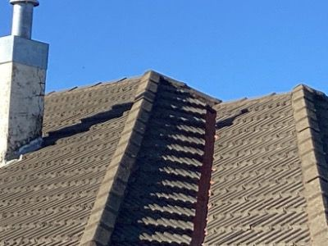
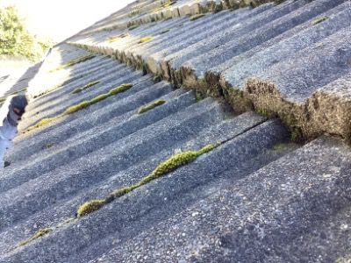

PREDOMINANT FLASHING MATERIAL (INCLUDING SIGNIFICANT MAINTENANCE)
TYPE


LEVEL OF CONCERN
G

PREDOMINANT GUTTER & DOWNPIPE MATERIAL (INCLUDING SIGNIFICANT MAINTENANCE)
TYPE

LEVEL OF CONCERN
G

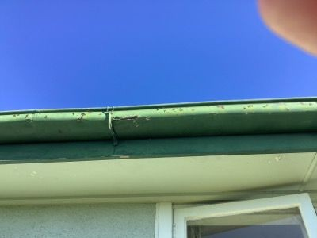

PREDOMINANT FASCIA & SOFFIT MATERIAL (INCLUDING SIGNIFICANT MAINTENANCE)
TYPE

LEVEL OF CONCERN
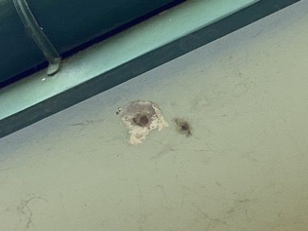
G

INDICATIONS OF WATER PENETRATION
LEVEL OF CONCERN
G

SUMMARY OF EXTERIOR ROOF
Below summarises your exterior roof inspection. If you have any further questions, please contact the office on 096 951 1777.
Predominant Roof Material (including significant maintenance) Predominant Flashing Material (including significant maintenance)
G
G
Predominant Gutter & Downpipe Material (including significant maintenance) Predominant Fascia & Soffit Material (including significant maintenance) Indications of Water Penetration
G
G
G
Obvious Structural Alterations
N
Functional Operation of Roof, Flashings, Gutters & Downpipes
G

OVERALL SECTION RATING
G

ROOF SPACE

INSPECTION FOCUS NO.2
This focus section covers the roof space. Please note our visual inspection provides an overall level of concern, rather than a detailed account of every minor defect which may not effect the overall structural integrity or function of the roof space.
There is generally limited space in roof cavities, particularly to the lower and outer portions of the building. This does restrict access and in most instances prevents an inspection of the outer or lower areas, including any roof to wall connections. If insulation is in place this will also restrict the inspectors visibility. Defects or damage may be present and not detected in areas where inspection was limited, obstructed or access was not gained.

RESTRICTIONS
The roof space inspection was limited. We could not complete a full inspection of the roof space. Our visual inspection was made from the inspection hatch. Only areas visible from the inspection hatch were observed and comments included in this report. This was due to insulation causing access restrictions.

INDICATIONS OF WATER PENETRATION
LEVEL OF CONCERN
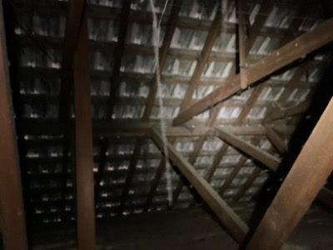
G

INTEGRITY OF ROOF STRUCTURE ELEMENTS
TYPE

LEVEL OF CONCERN
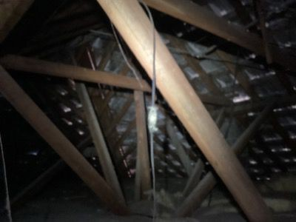
G

INSULATION
TYPE
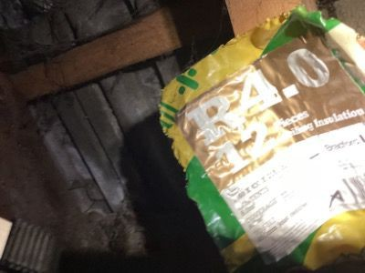

LEVEL OF CONCERN
G

FUNCTIONAL OPERATION OF ROOF STRUCTURE ELEMENTS (INCLUDING SERVICES)
LEVEL OF CONCERN
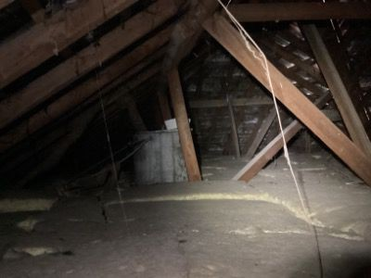
G

SUMMARY OF ROOF SPACE
Below summarises your roof space inspection. If you have any further questions, please contact the office on 096 951 1777.
Indications of Water Penetration Integrity of Roof Structure Elements Obvious Structural Alterations Insulation
G
G
G
G
Functional Operation of Roof Structure Elements (including services)
G

OVERALL SECTION RATING
G

EXTERNAL WALL CLADDING

INSPECTION FOCUS NO.3
The exterior wall cladding of the dwelling is visually inspected where accessible. Some limitations may occur due to the height of the dwelling, foliage near the cladding, site slope etc. Please note our visual inspection provides an overall level of concern, rather than a detailed account of every minor defect which may not effect the overall structural integrity or function of the exterior cladding.

RESTRICTIONS

EXTERIOR CLADDING MATERIAL (INCLUDING SIGNIFICANT MAINTENANCE)
TYPE

LEVEL OF CONCERN

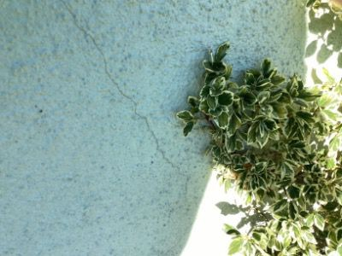
G

JOINERY MATERIAL (INCLUDING SIGNIFICANT MAINTENANCE)
TYPE

LEVEL OF CONCERN
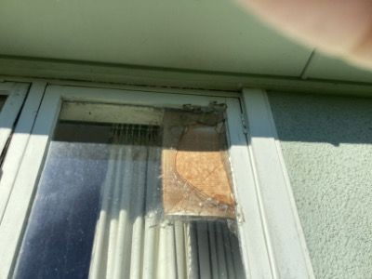
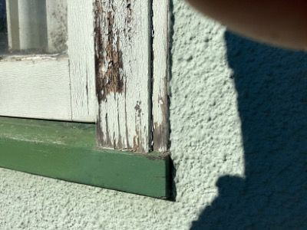
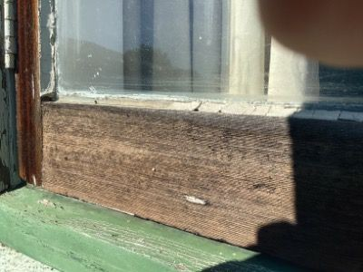
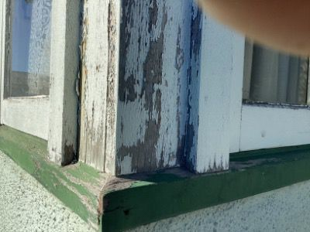
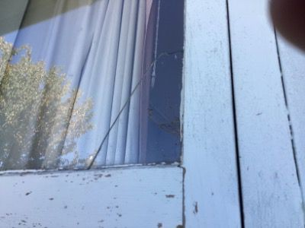
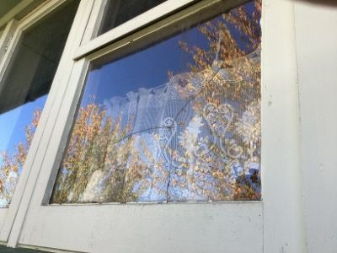
N

FUNCTIONAL OPERATION OF WALL CLADDING (INCLUDING WINDOW & DOOR FLASHINGS)
TYPE

LEVEL OF CONCERN
G

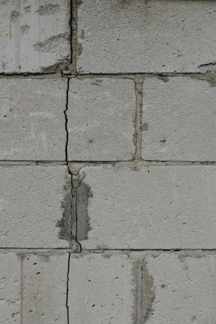

SUMMARY OF EXTERNAL WALL CLADDING
Below summarises your external wall cladding inspection. If you have any further questions, please contact the office on:- 096 951 1777
Exterior Cladding Material (including significant maintenance) Joinery Material (including significant maintenance)
G
N
Obvious Cladding Alterations
G
Functional Operation of Wall Cladding (including window & door flashings)
G

OVERALL SECTION RATING
G

FOUNDATION & SUBFLOOR

INSPECTION FOCUS NO.4
This section includes both the foundation and its supporting subfloor structure (if applicable). The inspection is done by entering the subfloor (any access restrictions will be identified). Please note concrete slab sub-floors are not inspected. Where piles are present we conduct a visual inspection above ground level only. Please note our visual inspection provides an overall level of concern, rather than a detailed account of every minor defect which may not effect the overall structural integrity or function of the foundations.

RESTRICTIONS
An area sub-floor was not able to be inspected. This was due to low floor height. This was due to low hanging pipes. This was due to safety reasons.

PREDOMINANT FOUNDATION MATERIAL (INCLUDING SIGNIFICANT MAINTENANCE)
TYPE

LEVEL OF CONCERN
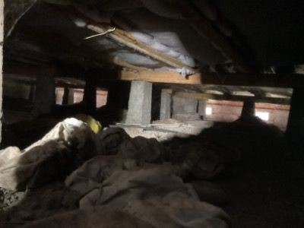
G

OBVIOUS CRACKING OR FOUNDATION DETERIORATION
LEVEL OF CONCERN
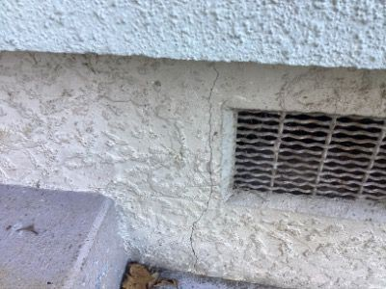
G

PILE TO BEARER CONNECTIONS (IF APPLICABLE)
TYPE

LEVEL OF CONCERN
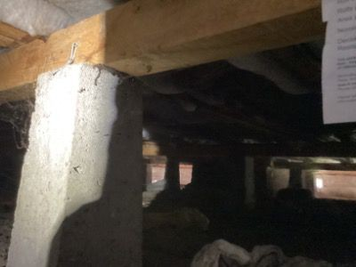
G

SUBFLOOR VENTILATION
TYPE

LEVEL OF CONCERN
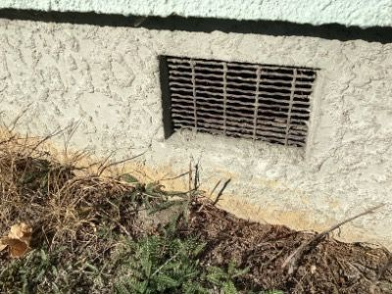
G

LEVEL OF CONCERN
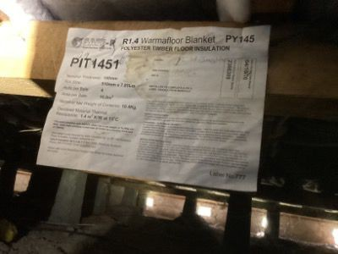
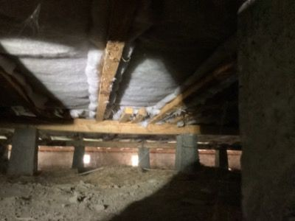
G

SUMMARY OF FOUNDATION & SUBFLOOR
Below summarises your foundation & subfloor inspection. If you have any further questions, please contact the office on 096 951 1777
Predominant Foundation Material (including significant maintenance) Obvious Cracking or Foundation Deterioration
G
G
Pile to Bearer Connections (if applicable) Subfloor Ventilation
G
G
Insulation
G
Indications of Water Leaks - Below Finished Floor Level Obvious Structural Alterations
G
G
Functional Operation of Foundation & Subfloor
G

OVERALL SECTION RATING
G

PLUMBING SYSTEM

INSPECTION FOCUS NO.5
This section includes both the water supply and waste water drainage. None of our inspectors are qualified Plumbers. Due to construction methods a large portion of the plumbing systems can be concealed within the building envelope. Our report covers only those areas able to be viewed by the inspector. Please note our visual inspection provides an overall level of concern, rather than a detailed account of every minor defect which may not affect the overall integrity or function of the water and drainage systems.

RESTRICTIONS
The plumbing was not visible due to the pipes being concealed in the wall. Overall the visible inspection showed plumbing to be in good condition

PREDOMINANT WASTE WATER MATERIAL (INCLUDING SIGNIFICANT MAINTENANCE)
TYPE

LEVEL OF CONCERN
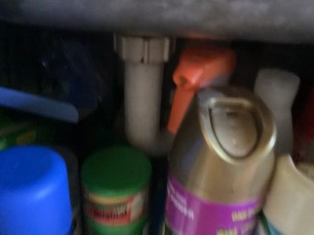
G

PREDOMINANT WATER SUPPLY PIPING (INCLUDING SIGNIFICANT MAINTENANCE)
TYPE

LEVEL OF CONCERN
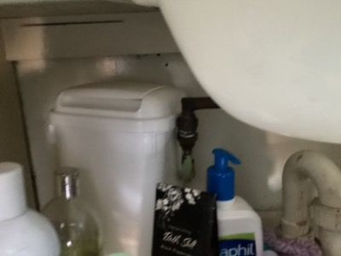
O

INDICATIONS OF WATER LEAKS - ABOVE FINISHED FLOOR LEVEL
LEVEL OF CONCERN
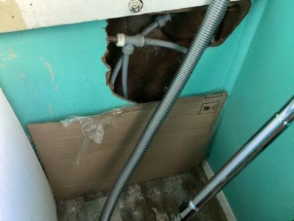
O

HOT WATER CYLINDER FUNCTION
TYPE

LEVEL OF CONCERN
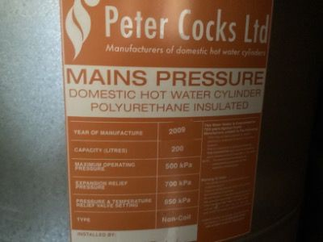
O

SOURCE OF WATER SUPPLY
TYPE
Well and City Water

LEVEL OF CONCERN
G

METHOD OF WASTE WATER DISPOSAL
TYPE
City

LEVEL OF CONCERN
G

FUNCTIONAL OPERATION OF PLUMBING SYSTEM
LEVEL OF CONCERN
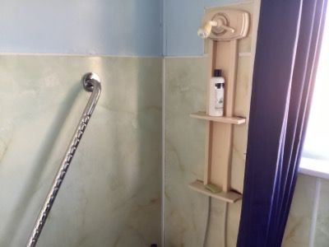
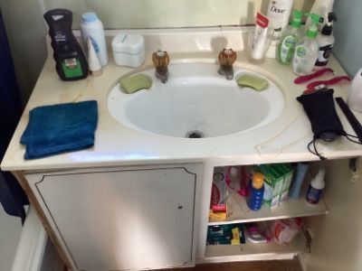
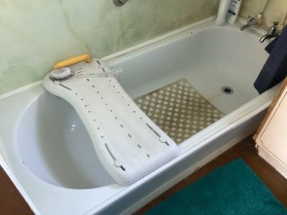
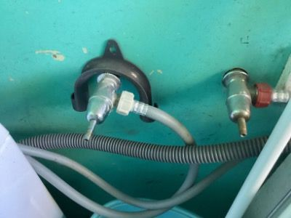
N

FUNCTIONAL OPERATION OF FIXTURE & FITTINGS
LEVEL OF CONCERN
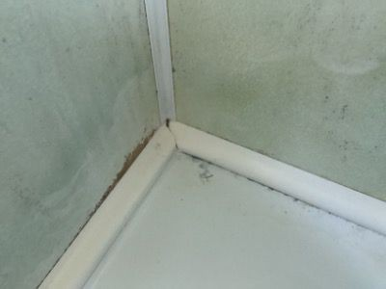
O

SUMMARY OF PLUMBING SYSTEM
Below summarises your plumbing system inspection. If you have any further questions, please contact the office on 096 951 1777
Predominant Waste Water Material (including significant maintenance) Predominant Water Supply Piping (including significant maintenance) Predominant Water Supply Piping (including significant maintenance) Indications of Water Leaks - Above Finished Floor Level
G
O
O
O
Hot Water Cylinder Function Source of Water Supply
O
G
Method of Waste Water Disposal Functional Operation of Plumbing System Functional Operation of Fixture & Fittings
G
N
O

OVERALL SECTION RATING
O

ELECTRICAL SYSTEM

INSPECTION FOCUS NO.6
This section includes the electrical system. None of our inspectors are qualified Electricians. Due to construction methods a large portion of the electrical systems can be concealed within the building envelope. Our report covers only those areas able to be viewed by the inspector. No testing or commenting on the function, defects and concern level of appliances (ovens, hobs & range hoods etc) is undertaken. Please note a sampling of outlets will be tested for function, not every outlet. Please note our visual inspection provides an overall level of concern, rather than a detailed account of every minor defect which may not affect the overall integrity or function of the electrical system.

RESTRICTIONS
The wiring was only visible in certain areas of the sub-floor. This was due to low floor height. This was due to low hanging pipes. This was due to safety reasons.

VISIBLE SIGNS OF CONDUIT, VIR OR TRS WIRING
TYPE

LEVEL OF CONCERN
G

CIRCUIT BREAKER ESTIMATED ERA
TYPE

LEVEL OF CONCERN
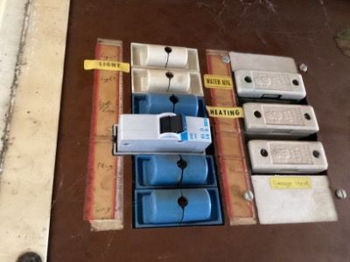
G

ELECTRICITY SOURCE
TYPE

Standard Wiring to the property

LEVEL OF CONCERN
G

SIGNIFICANT MAINTENANCE REQUIRED
LEVEL OF CONCERN
O

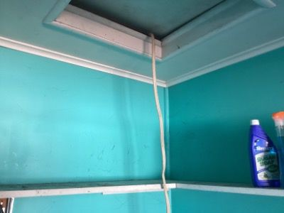

SUPPLY OF ELECTRICITY FUNCTIONAL OPERATION (BASED ON SAMPLING OF OUTLETS & LIGHTS)
LEVEL OF CONCERN
N

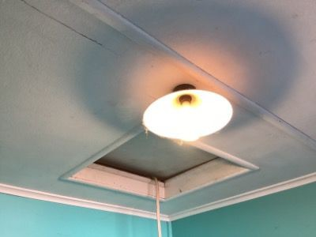
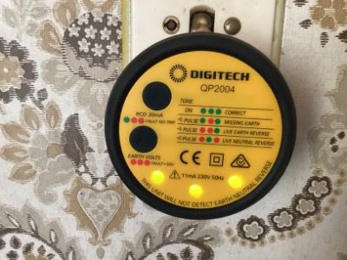

SUMMARY OF ELECTRICAL SYSTEM
Below summarises your electrical system inspection. If you have any further questions, please contact the office on 096 951 1777
Visible Signs of Conduit, VIR or TRS Wiring Circuit Breaker Estimated Era
G
G
Electricity Source
G
Significant Maintenance Required
O
Supply of Electricity Functional Operation (based on sampling of outlets & lights)
N

OVERALL SECTION RATING
O

WEATHER TIGHTNESS
INSPECTION FOCUS NO.7
Assessing the weather tightness of a building non-invasively is an art. There is a range of factors that need to be taken into account when concluding the overall state of weather tightness (see below). A moisture meter is one tool we utilise to identify moisture. We also consider the building design and structure. Refer to text on following page for further detail.
UNDERSTANDING YOUR MOISTURE READINGS
- The only accurate way to measure moisture is intrusively; this is NOT practiced during our visual property inspection. Therefore this report cannot give any weather tightness guarantee. Any clear signs of moisture ingress are noted and spot checks are carried out primarily around windows, doors and high risk areas with a moisture meter. All inspectors use either a Protimeter Survey Master or Trotec T660 moisture meter, calibrated to the manufacturer’s specifications. This device is used in its Non-invasive mode and while this mode is deemed non-conclusive, it is a good indicator of the potential presence of moisture.
- The moisture meter in the non-invasive mode is not an accurate moisture reading. Readings are determined by what is known as a ‘Relative moisture level’. Firstly a “Base” moisture level for the property is ascertained (by undertaking a selection of tests in low risk areas such as a central hallway where low moisture levels are expected). Then a selection of potential high risk areas are taken in areas which the inspector believes are high risk.
- All “betta inspect it” Inspectors are trained in the correct use of the moisture meters, with a good understanding of their abilities and limitations.
- The lack of moisture indicators does not confirm that the property does not have moisture issues. Water accumulates and travels immediately behind the external cladding; the external cladding is ideally what should be tested. However, this is not practical, nor possible with some claddings and weather conditions, therefore the meters are predominately used for the interior of the building. As visual inspections are non-invasive testing may provide no initial evidence of leaking, knowledge of known weather tight risk details and/or signs to look for become more critical. Further investigation will be recommended where there is sufficient evidence and concern that it may reveal signs of severe moisture penetration. Moisture levels can change significantly with the seasons and can often be much lower in advanced decay. The same can incur with leaks in plumbing where plumbing has not been used for a period of time in a manner causing the moisture and as a result allowing the area to dry out.
MOISTURE METER USED
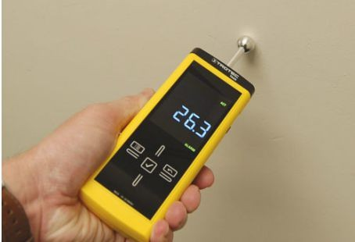
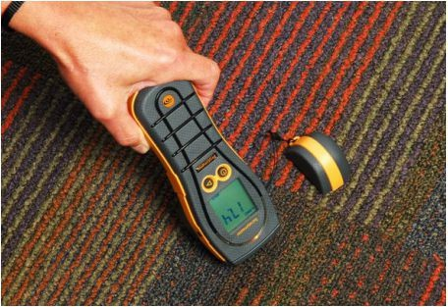
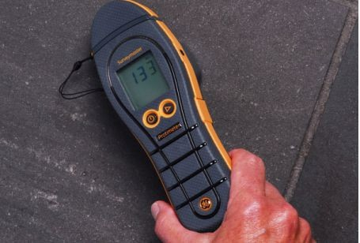

UNDERSTANDING THE READINGS

Red = Very High
Relative moisture reading is being 81 points above the benchmark on a relative scale. This indicates very high levels of moisture behind the wall. Further investigation is required prior to purchasing the house. Invasive testing is recommended.

Orange = Higher
Relative moisture readings 41 - 80 points above the benchmark on a relative scale. This indicates moisture in the wall. Possible causes could be the wall faces south, vegetation could be in close proximity to the buildings envelope or water ingress. There is the potential for timber in this area to harbour toxic mould growth and potential timber decay. We recommend a further investiagation by a thermographer or weather tightness specialist prior to purchasing the property.

Green = Normal
Relative moisture reading is within 40 points of the benchmark on a relative scale.

FRAMING & ATTACHMENT TO CLADDING
TYPE

LEVEL OF CONCERN
G



METHOD OF DISCHARGING ROOF COLLECTED RAIN WATER
TYPE

LEVEL OF CONCERN
G

SOFFIT DEPTH
TYPE

LEVEL OF CONCERN
G



ESTIMATED ERA OF BUILDING CONSTRUCTION
TYPE

LEVEL OF CONCERN
G

OTHER RISK FACTORS (INCLUDING WIND ZONE & NUMBER OF STORIES)
TYPE

LEVEL OF CONCERN
G

OTHER
LEVEL OF CONCERN
N

PREVALENT WEATHER CONDITIONS (ONE MONTH PRIOR)
LEVEL OF CONCERN
G

BENCH MARK READING
READING LOCATION

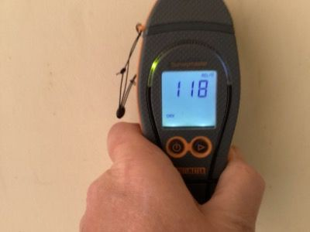

LEVEL OF CONCERN
G

MOISTURE READING #1
READING LOCATION

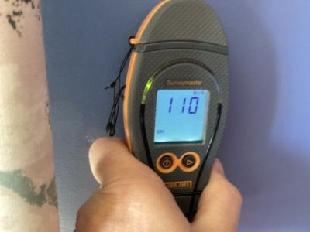

LEVEL OF CONCERN
G

MOISTURE READING #2
READING LOCATION

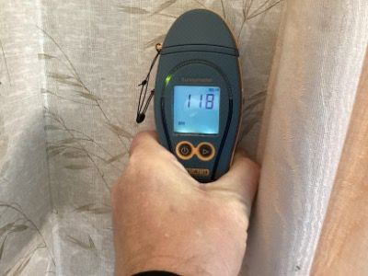

LEVEL OF CONCERN
G

MOISTURE READING #3
READING LOCATION

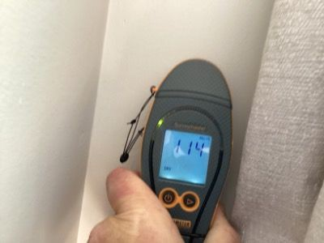

LEVEL OF CONCERN

MOISTURE READING #4
READING LOCATION

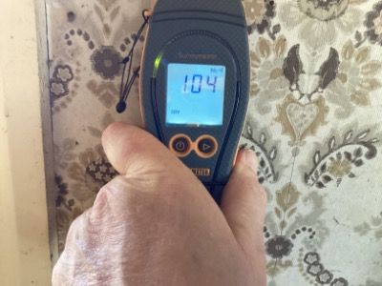

LEVEL OF CONCERN
G

MOISTURE READING #5
READING LOCATION
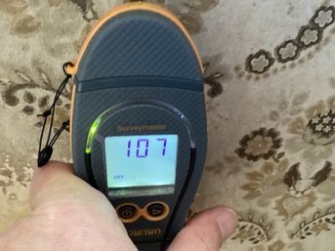

LEVEL OF CONCERN

MOISTURE READING #6
READING LOCATION
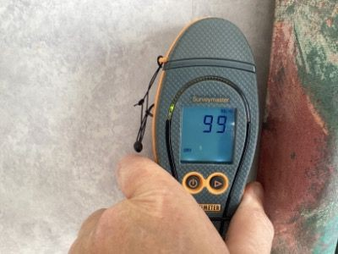

LEVEL OF CONCERN
G

MOISTURE READING #7
READING LOCATION
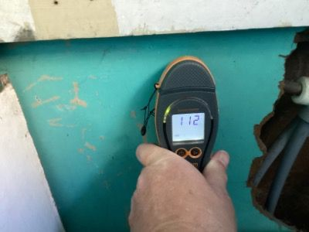

LEVEL OF CONCERN

SUMMARY OF WEATHER TIGHTNESS
Below summarises your weather tightness. If you have any further questions, please contact the office on 096 951 1777

Framing & Attachment to Cladding
G
Method of Discharging Roof Collected Rain Water High Risk Junctions
G
G
Decks & Balconies Soffit Depth
G
G
Estimated Era of Building Construction Complexity of Building Design
G
G
Other Risk Factors (including wind zone & number of stories) Prevalent Weather Conditions (One Month Prior)
G
G
Moisture Reading #1
G
Moisture Reading #2
G
Moisture Reading #3
G
Moisture Reading #4
G
Moisture Reading #5
G
Moisture Reading #6
G
Moisture Reading #7
G
Moisture Reading #8
N
Moisture reading around shower or bath
G

OVERALL SECTION RATING
G

SITE IMPROVEMENTS

INSPECTION FOCUS NO.8
This section includes the site and site improvements. Our inspectors are NOT qualified Geotech engineers and therefore the report cannot include geotechnical issues (current or historic). Liquefaction zones and flood plains are not commented on along with the site boundaries. We do not comment on any soil, site strength or stability. Only the main outbuilding will be included in our assessment, unless specifically requested. Please note our visual inspection provides an overall level of concern, rather than a detailed account of every minor defect which may affect the overall integrity or function of the site and site improvements.

SITE IMPROVEMENTS (INCLUDING VISUAL SITE DRAINAGE)
LEVEL OF CONCERN
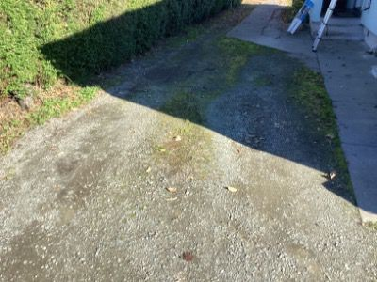
O

OUTBUILDINGS & OTHER STRUCTURES
TYPE

Garage type building
LEVEL OF CONCERN
O

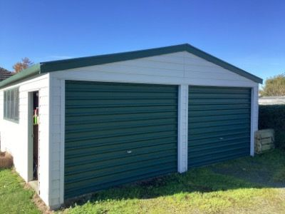

SUMMARY OF SITE IMPROVEMENTS
Below summarises your site improvements. If you have any further questions, please contact the office on 096 951 1777
Site Improvements (including visual site drainage) Outbuildings & Other Structures
O
O

OVERALL SECTION RATING
O

PEST & POTENTIAL HAZARDS

INSPECTION FOCUS NO.9
This section includes both signs of pest infiltration and potential hazards. Please note our visual inspection provides an overall level of concern, rather than a detailed account of every minor aspect relating to pests and hazards.

RESTRICTIONS
Refer to subfloor section. Refer to roof space section.

SIGNIFICANT EVIDENCE OF BORER
LEVEL OF CONCERN
G

SIGNIFICANT EVIDENCE OF TERMITES
LEVEL OF CONCERN
G

IDENTIFIED ASBESTOS
TYPE

LEVEL OF CONCERN
G

IDENTIFIED PEST INFILTRATION
TYPE

LEVEL OF CONCERN
G

SUMMARY OF PEST & POTENTIAL HAZARDS
Below summarises your pest & potential hazards inspection. If you have any further questions, please contact the office on 096 951 1777
Significant Evidence of Ants Significant Evidence of Termites Identified Asbestos
G
G
G
Observed Occurrences of Mold and Mildew Identified Pest Infiltration
G
G

OVERALL SECTION RATING
G

OTHER POINTS OF INTEREST

INSPECTION FOCUS NO.10
This section includes other significant points of interest that we believe are important to know prior to settling on your desired property. Evidence of scrim wall lining can often be hard to determine as it is often covered with other lining. Floors are often slightly un-level; only significant unevenness will be commented on. The function of the heating and ventilation systems will not be tested, only being visually inspected. Please note our visual inspection provides an overall level of concern, rather than a detailed account of every minor defect which may affect the overall integrity or function of the property.

RESTRICTIONS
The quantity of furniture within the house meant we had limited ability to inspect the house. The floor coverings within the house meant we had limited ability to inspect the house. The interior side of the window joinery was covered by curtains we had limited ability to inspect these windows.

SIGNIFICANT INTERIOR CEILING DAMAGE OR DEFECTS
LEVEL OF CONCERN
G

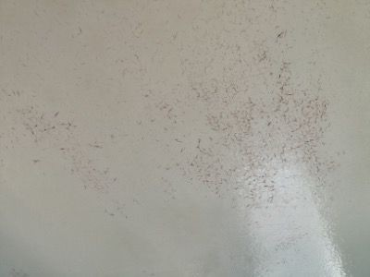
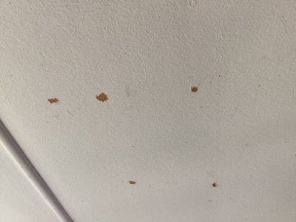
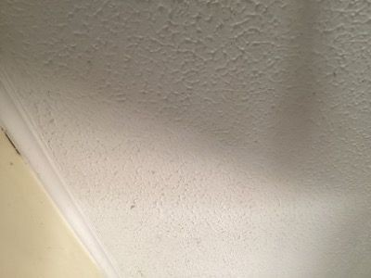

SIGNIFICANT INTERIOR WALL DAMAGE OR DEFECTS
LEVEL OF CONCERN
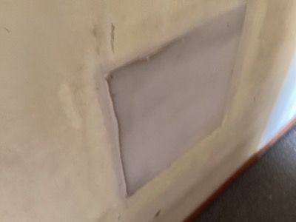
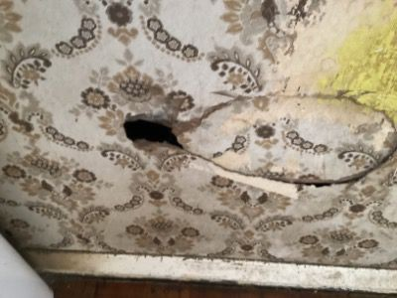
O

SIGNIFICANT INTERIOR FLOOR DAMAGE OR DEFECTS
LEVEL OF CONCERN
G

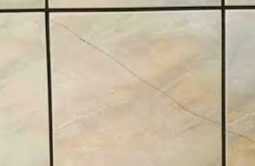

We discovered cracked floor tiles in several areas, which could indicate underlying structural problems or poor installation. These cracks may lead to further damage and pose safety risks if not addressed promptly.

SIGNIFICANT INTERIOR FIXTURE & FITTINGS DAMAGE OR DEFECTS
LEVEL OF CONCERN
O

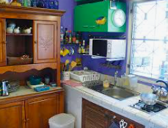
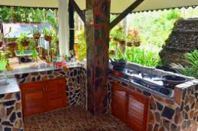
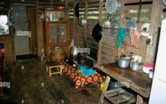

BATHROOM VENTILATION
TYPE

LEVEL OF CONCERN
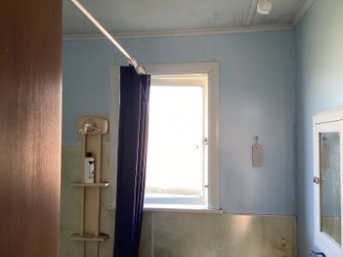
G

LAUNDRY VENTILATION
TYPE

LEVEL OF CONCERN
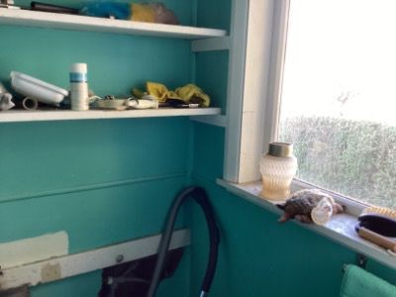
G

PRESENCE OF SMOKE ALARM
TYPE

LEVEL OF CONCERN
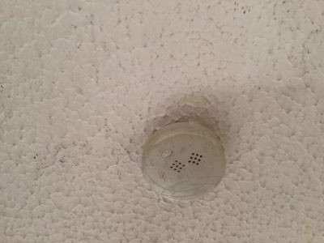
G

TYPE OF ENERGY SOURCE SERVICING APPLIANCES
TYPE

LEVEL OF CONCERN
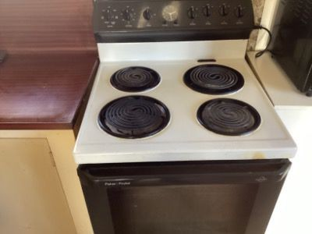
G

OBSERVATIONS OF EXTERNAL JOINERY FROM INTERIOR
LEVEL OF CONCERN
O

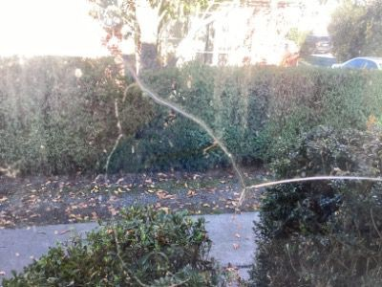
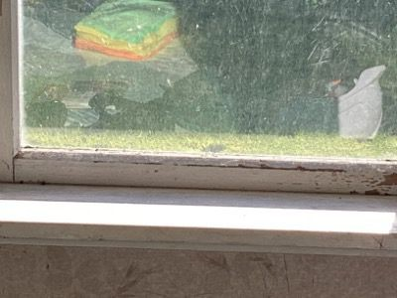

SUMMARY OF OTHER POINTS OF INTEREST
Below summarises your other points of interest. If you have any further questions, please contact the office on:-
Significant Interior Ceiling Damage or Defects Significant Interior Wall Damage or Defects Significant Interior Floor Damage or Defects
G
O
G
Significant Interior Fixture & Fittings Damage or Defects Evidence of Potential Scrim
O
G
Evidence of Un-Level Flooring Home Heating (including chimneys) Bathroom Ventilation
G
G
G
Laundry Ventilation
G
Obvious Internal Structural Alterations Presence of Smoke Alarm
G
G
Significant Security Concerns (including alarm system) Type of Energy Source Servicing Appliances
G
G
Presence of Converted Living Spaces (eg converted garage to room) Dwelling Systems (including central vacuum & ventilation) Observations of external joinery from Interior
G
G
O

OVERALL SECTION RATING
O

ADDITIONAL NOTES



Our Terms &
Conditions

SCOPE OF INSPECTION
Particulars
C. The parties are Joe Andrews, representing Property Inspections Phuket, and the property owner, Ms. Ananya Thongchai. Joe Andrews will conduct the inspection, and Ms. Thongchai has provided full access to the property. Both parties agree to the terms outlined in the inspection agreement.

Definitions

- Price & Payment

- Time of Supply
- Consumer Guarantees Act

- Intellectual Property and Confidentiality

- Default

- Cancellation
- Privacy Act 1993

- Inspectors have no personal interest

- Scope of Works - Building Inspection and Report

10.2 Both parties agree to the terms outlined in the inspection agreement. All legal jurisdictions shall be those of the Kingdom of Thailand.

- Reasonable Access

- Limitation of Liability

14. General

